Piece Parts and Sub-Contracted Assemblies Traceability Barcoding User’s Guide

BAE SYSTEMS
Information & Electronic Systems Integration, Inc.
PO Box 868
Nashua NH
03061-0868

CAGE: 94117

DISTRIBUTION STATEMENT F: Further dissemination only as directed by the Project Office, MDA/TH, Bldg. 5222 Martin Road, Redstone Arsenal, AL 35898 or higher authority.

WARNING: This document/software contains technical data/software whose export is restricted by the Arms Export Control Act (Title 22, U.S.C., Sec 2751 et seq.) or the Export Administration Act of 1979, as amended, (Title 50, U.S.C., App 2401 et seq). Violations of these export laws are subject to severe criminal penalties. Disseminate in accordance with provisions of DOD Directive 5230.25.

DESTRUCTION NOTICE: For classified documents, follow the procedures in DOD 5220.22 M, National Industrial Security Program Operating Manual, Chapter 5, Section 7, or DOD 5200.1 R, Information Security Program Regulation, Chapter 6, Section 7. For unclassified, limited documents, destroy by any method that will prevent disclosure of contents or reconstruction of the document.

DISTRIBUTION STATEMENT F: Further dissemination only as directed by the Project Office, MDA/TH, Bldg. 5222 Martin Road, Redstone Arsenal, AL 35898 or higher authority.

WARNING: This document/software contains technical data/software whose export is restricted by the Arms Export Control Act (Title 22, U.S.C., Sec 2751 et seq.) or the Export Administration Act of 1979, as amended, (Title 50, U.S.C., App 2401 et seq). Violations of these export laws are subject to severe criminal penalties. Disseminate in accordance with provisions of DOD Directive 5230.25.

DESTRUCTION NOTICE: For classified documents, follow the procedures in DOD 5220.22 M, National Industrial Security Program Operating Manual, Chapter 5, Section 7, or DOD 5200.1 R, Information Security Program Regulation, Chapter 6, Section 7. For unclassified, limited documents, destroy by any method that will prevent disclosure of contents or reconstruction of the document.

DISTRIBUTION STATEMENT F: Further dissemination only as directed by the Project Office, MDA/TH, Bldg. 5222 Martin Road, Redstone Arsenal, AL 35898 or higher authority.

WARNING: This document/software contains technical data/software whose export is restricted by the Arms Export Control Act (Title 22, U.S.C., Sec 2751 et seq.) or the Export Administration Act of 1979, as amended, (Title 50, U.S.C., App 2401 et seq). Violations of these export laws are subject to severe criminal penalties. Disseminate in accordance with provisions of DOD Directive 5230.25.

DESTRUCTION NOTICE: For classified documents, follow the procedures in DOD 5220.22 M, National Industrial Security Program Operating Manual, Chapter 5, Section 7, or DOD 5200.1 R, Information Security Program Regulation, Chapter 6, Section 7. For unclassified, limited documents, destroy by any method that will prevent disclosure of contents or reconstruction of the document.

- Requirements
  - Trace Information
    - Suppliers
      - Contract Need
The Program has a contractual requirement covering piece-parts. This includes parts modified to meet a physical need and parts screened to meet an operational requirement. These Suppliers shall provide component traceability documentation.
      - Documentation Quality
Component trace documentation shall be complete, correct, legible and in the case of barcodes - scannable.
      - Barcoding to Achieve Data Integrity
Component trace documentation shall use barcoding.
      - Suppliers Providing Trace Information
“Suppliers” consist of companies manufacturing the original component or equipment: Original Component/Equipment Manufacturers (OCMs or OEMs) and companies adding value through component/equipment enhancements: Value Added Houses (VAHs).

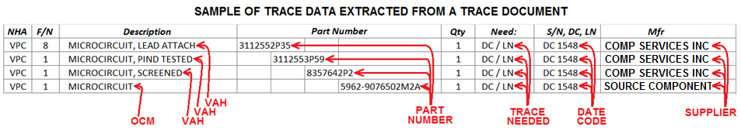
Figure 1
Trace data must be provided for every level of a component’s assembly and screening.
Note: Regarding Figure 1, the 3112552P35 part number is the “Top-Tier Part Number.” The two indented levels below the top tier are “Middle-Tier Part Numbers.” There can be as many as three Middle-Tier Part Numbers. The lowest tier is always the Original Component Manufacturer. It is the “Bottom-Tier Part Number.”

Figure 2

      - Original Component Manufacturers - Barcoding
        - Requirement
Original Component/Equipment Manufacturer (OCM/OEM) shall provide the following traceable information:
- Original Component or Equipment Manufacturer’s Name
- Original Component or Equipment Manufacturer’s CAGE Code (Note 1)
- Part Number (Note 2)
- Purchase Order Number
- Serial Number (Note 3)
- Date Code (Note 4)
- Lot Number (Note 5)
- Revision (Note 6)
- Quantity
Note 1: The CAGE Code shall be the CAGE Code from the “Original Component Manufacturer’s” manufacturing address.
Note 2: The Part Number shall be the OCM’s Part Number.
Note 3: Serial Numbers are rarely used with Original Component Manufacturer’s piece parts. However, if there is a Serial Number then it shall be entered into the traceability paperwork as both text and barcode. If there is no Serial Number then leave both the text and barcode fields populated with “NA.”
Note 4: Date Codes may or may not be used by Original Component Manufacturers. If there is a Date Code then it shall be entered into the traceability paperwork as both text and barcode. If there is no Date Code then leave both the text and barcode fields populated with “NA.”
Note 5: Lot Numbers may or may not be used by Original Component Manufacturers. If there is a Lot Number then it shall be entered into the traceability paperwork as both text and barcode. If there is no Lot Number then leave both the text and barcode fields populated with “NA.”
Note 6: The Revision consists of two parts: the Hardware Revision and the Drawing Revision captured as alpha characters for BAE Systems’ part numbers. Example: “REV A/B.” Revisions may or may not be used by Value Added Houses. If there is a Revision then it shall be entered into the traceability paperwork as both text and barcode. If there is no Revision then leave both the text and barcode fields populated with “NA.”
Note 7: Trace information shall be included with the paperwork provided by the Original Component Manufacturer. It may be included within an existing document or as a separate sheet.

        - Original Component Manufacturer Barcoding Example
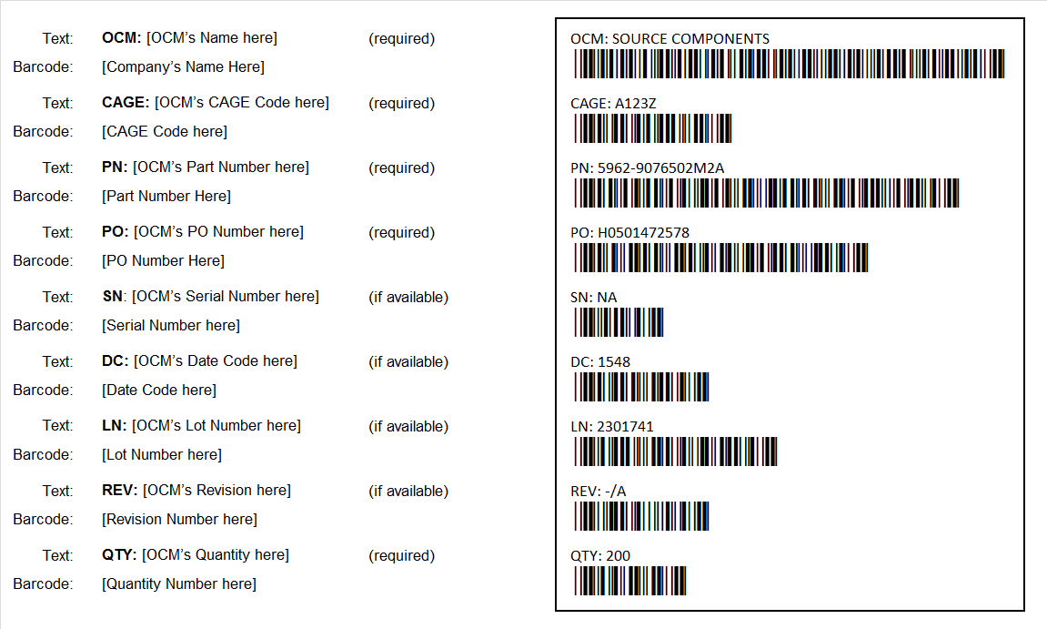
Figure 3
Note: All text and field values shown in the barcode image (OCM, CAGE, PN, PO, SN, DC, LN, REV and QTY) are examples only.
Note: The readable text shall be 11 point size Calibri font. Barcodes shall be either 24 or 26 point size “3 of 9 barcode” font.
Note: This barcode example has been built using Panel 01 from Figure 2 as a reference.
      - Value Added House: Barcoding
        - Requirement
Value Added Houses (VAHs) shall provide the following traceable information:
- Value Added Houses’ Name
- Value Added Houses’ CAGE Code (Note 8)
- Part Number (Note 9)
- Purchase Order Number
- Serial Number (Note 10)
- Date Code (Note 11)
- Lot Number (Note 12)
- Revision (Note 13)
- Quantity
Note 8: The CAGE Code shall be the CAGE Code from the “Value Added Houses’ manufacturing address.
Note 9: The Part Number shall be the BAE System’s Part Number.
Note 10: Serial Numbers are rarely used with Value Added Houses’ piece parts. However, if there is a Serial Number then it shall be entered into the traceability paperwork as both text and barcode. If there is no Serial Number then leave both the text and barcode fields populated with “NA.”
Note 11: Date Codes may or may not be used by Value Added Houses. If there is a Date Code then it shall be entered into the traceability paperwork as both text and barcode. If there is no Date Code then leave both the text and barcode fields populated with “NA.”
Note 12: Lot Numbers may or may not be used by Value Added Houses. If there is a Lot Number then it shall be entered into the traceability paperwork as both text and barcode. If there is no Lot Number then leave both the text and barcode fields populated with “NA.”
Note 13: Revisions consists of two parts: the Hardware Revision followed by the Drawing Revision. These are captured as alpha characters for BAE Systems’ part numbers. Example: “REV C/A.” If the Value Added House uses a Revision then it shall be entered into the traceability paperwork as both text and barcode. If the Value Added House inherits Revision information then it shall be entered into the traceability paperwork as both text and barcode. If there is no Revision then leave both the text and barcode fields populated with “NA.”
Note 14: Trace information shall be included with the paperwork provided by the Value Added House. It may be included within an existing document or as a separate sheet.

        - Value Added House Barcoding Example
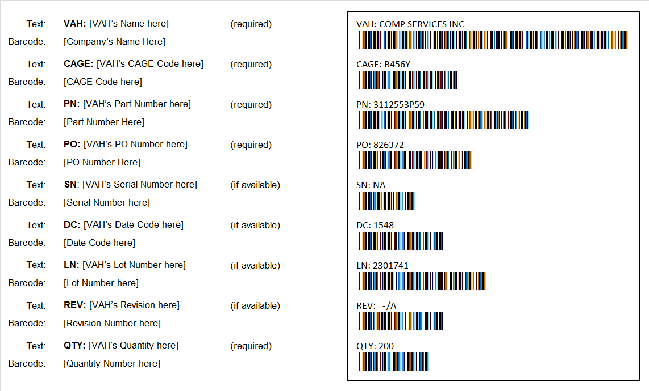
Figure 4
Note: All text and field values shown in the barcode image (VAH, CAGE, PN, PO, SN, DC, LN, REV and QTY) are examples only.
Note: The readable text shall be 11 point size Calibri font. Barcodes shall be either 24 or 26 point size “3 of 9 barcode” font.
Note: This barcode example has been built using Panel 01 from Figure 2 as a reference.
      - Distributors: Barcoding
        - Requirement
Value Added Houses (VAHs) shall provide the following traceable information:
- Distributor’s Name
- Distributor’s CAGE Code (Note 15)
- OCM’s Part Number (Note 16)
- Purchase Order Number (Note 17)
- OCM’s Serial Number (Note 18)
- OCM’s Date Code (Note 19)
- OCM’s Lot Number (Note 20)
- OCM’s Revision (Note 21)
- Distributor’s Quantity
Note 15: The CAGE Code shall be the CAGE Code from the Distributor’s address.
Note 16: The Part Number shall be the OCM’s Part Number.
Note 17: The Purchase Order Number shall be the Purchase Order number from the company placing the original Purchase Order.
Note 18: The Serial Number, if one applies, shall be the OCM’s Serial Number. If there is no Serial Number then leave both the text and barcode fields populated with “NA.”
Note 19: The Date Code, if one applies, shall be the OCM’s Date Code. If there is no Date Code then leave both the text and barcode fields populated with “NA.”
Note 20: The Lot Number, if one applies, shall be the OCM’s Lot Number. If there is no Lot Number then leave both the text and barcode fields populated with “NA.”
Note 21: The Revision, if one applies, shall be the OCM’s Revision. If there is no Revision then leave both the text and barcode fields populated with “NA.”
Note: Revisions consists of two parts: the Hardware Revision followed by the Drawing Revision. These are captured as alpha characters for BAE Systems’ part numbers. Example: “REV C/A.”
Note 22: Trace information shall be included with the paperwork provided by the Distributor. It may be included within an existing document or as a separate sheet.

        - Distributor Barcoding Example
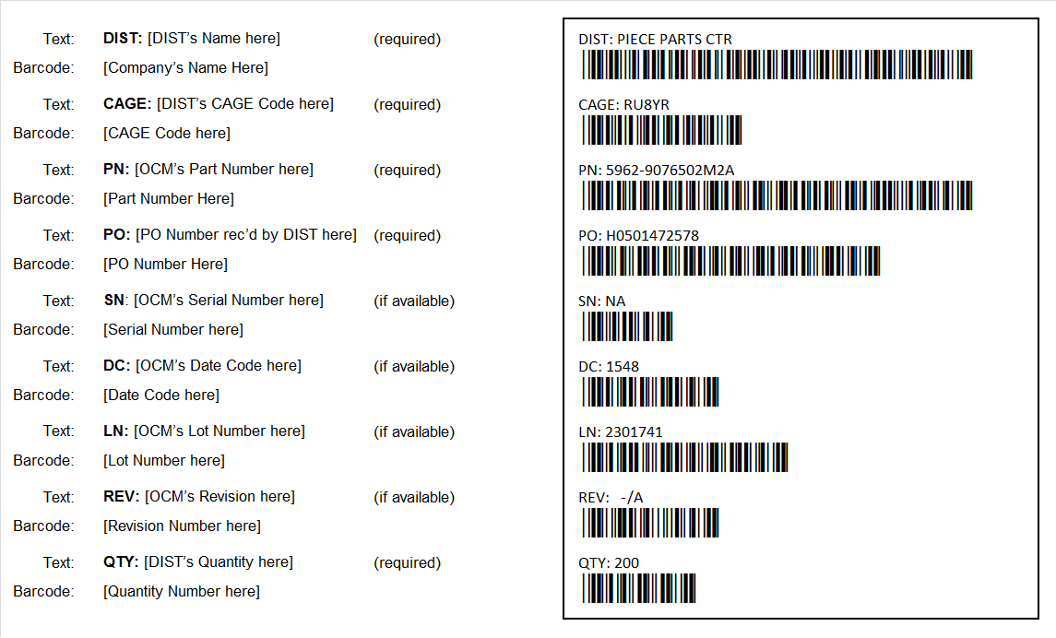
Figure 5
Note: All text and field values shown in the barcode image (DIST, CAGE, PN, PO, SN, DC, LN, REV and QTY) are examples only.
Note: The readable text shall be 11 point size Calibri font. Barcodes shall be either 24 or 26 point size “3 of 9 barcode” font.
Note: This barcode example has been built using Panel 01 from Figure 2 as a reference.

- Eliminating Transcription Errors
  - Ensure Barcodes Used by Suppliers
In order to ensure error free component traceability documentation, Suppliers shall use apply barcoded traceability to paperwork.
  - Ensure Receiving Personnel Scans Barcoded Documentation
Barcodes provide the means for eliminating errors caused by transcription.
Once barcoding methods have become part of a Supplier’s or Customer’s processes barcode scanning shall be used to transfer information.
In order to ensure the integrity of the trace is maintained, when extracting information from the barcoded paperwork:
- Choose the form and field into which the information needs to be recorded
- Click on the field
- Scan the barcoded information into the field.
  - Test Barcode Integrity using Barcode Scanner
Verify barcodes work by scanning them before the product moves to the next process point.
When in regular operation, periodically scan barcodes to verify that they are readable.

- Barcoding Aids and Guidelines
  - MIL-STD-130N
Barcodes shall comply with, Section 5.2.3.1, pertaining to linear bar code symbols. Refer to the following section extracted from MIL-STD-130N:
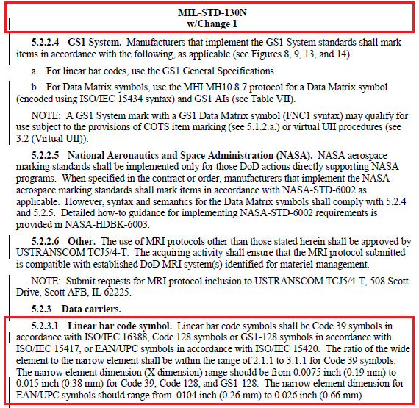
  - Creating Barcodes using MS Windows Fonts
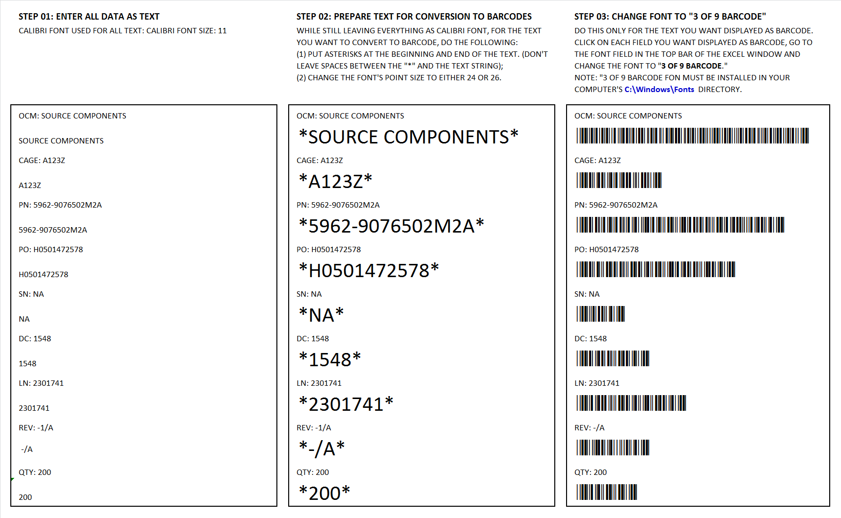
Figure 6

  - Barcode Field Details
Traceability Data Type | Requirements | Example
Original Component Manufacturer (OCM) | The OCM’s name is required and shall be placed on the traceability documentation. The OCM’s information shall consist of the following:  - A text string with “OCM: ” followed by the OCM’s name,  - A linear (one dimensional) barcode consisting of the OCM’s name only.  Note: Do not include “OCM: ” in the barcode. | 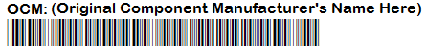
Value Added House (VAH) | The Value Added House’s name is required and shall be placed on the traceability documentation. The Value Added House’s information shall consist of the following:  - A text string with “VAH: ” followed by the Value Added House’s name,  - A linear (one dimensional) barcode consisting of the Value Added House’s name only.  Note: Do not include “VAH: ” in the barcode. | 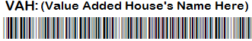
Distributor (DIST) | The Distributor’s name is required and shall be placed on the traceability documentation. The Distributor’s information shall consist of the following:  - A text string with “DIST: ” followed by the Distributor’s name.  - A linear (one dimensional) barcode consisting of the Supplier’s name or Distributor’s name only.  Note: Do not include “DIST: ” in the barcode. | 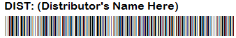
CAGE Code (CAGE) | The CAGE Code is required and shall be placed on the traceability documentation. The CAGE Code information shall consist of the following:  - An alpha-numeric text string with “CAGE: ” followed by the CAGE Code,  - A linear (one dimensional) barcode consisting of the CAGE Code only.  Note 1: Do not include “CAGE: ” in the barcode.  Note 2: CAGE Codes are required for all OCMs VAHs and Suppliers/Distributors in the traceability chain. | 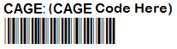
Part Number (PN) | The Part Number is required and shall be placed on the traceability documentation. The Part Number information shall consist of the following:  - An alpha-numeric text string with “PN:” followed by a space and then followed by the Part Number,  - A linear (one dimensional) barcode consisting of the Part Number only.  Note: Do not include “PN: ” in the barcode. | 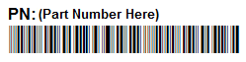
Purchase Order Number (PO) | The Purchase Order Number is required and shall be placed on the traceability documentation. The Purchase Order number information shall consist of the following:  - A numeric text string with “PO: ” followed by the Purchase Order number,  - A linear (one dimensional) barcode consisting of the Purchase Order number only.  Note: Do not include “PO: ” in the barcode. | 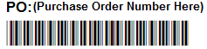
Serial Number (SN) | If the part comes with a Serial Number, and QA Code 128 has been invoked on the Purchase Order, then the Serial Number is required and shall be placed on the traceability documentation. The Serial Number’s information shall consist of the following:  - An alpha-numeric text string with “SN: ” followed by the Serial Number  - A linear (one dimensional) barcode consisting of the Serial Number only  Note 1: Do not include “SN: ” in the barcode.  Note 2: If there is a Serial Number for the part then the Serial Number must be captured on the paperwork.  Note 2: If there are multiple parts then there will be multiple Serial Numbers. The Serial Numbers may be placed on a single line separated by commas, each with an individual barcode. | 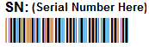
Date Code (DC) | If the part comes with a Date Code, then it is required that the Date Code be captured on the traceability documentation. The Date Code’s information shall consist of the following:  - An alpha-numeric text string with “DC: ” followed by the Date Code,  - A linear (one dimensional) barcode consisting of the Date Code only,  Note 1: Do not include “DC: ” in the barcode.  Note 2: If the set of parts consists of more than one Date code, then the quantities of parts with same date code shall be clustered together on the traceability document with the common date code associated its quantity. Provide as many separate same date codes with associated quantities as needed. Refer to Table 2.  Note 3: The Date code shall be captured in “YYWW” (Year-Year, Week-Week) format.  Note 4: If there are alpha-numeric characters attached to the front of the date code and alpha characters attached to the tail end of the date code then all characters must be included in the date code. Refer to section 2.2 for additional date code identification information as called out in MIL-PRF-38535K, Appendix A, (Section A.3.6.3.1 and Section A.3.6.3.2).  Date Code Text Examples: DC 1512, DC 1512A, DC 1512B, DC 1512AA, DC 1512R, DC 6B1610AB | 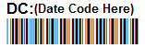
Lot Number (LN) | If the part comes with a Lot Number, then it is required that the Lot Number be captured on the traceability documentation. The Lot Number’s information shall consist of the following:  - An alpha-numeric text string with “LN: ” followed by the Lot Number,  - A linear (one dimensional) barcode consisting of the Lot Number only,  Note 1: Do not include “LN: ” in the barcode.  Note 2: the set of parts consists of more than one lot number, then the quantities of parts with same lot number shall be clustered together on the traceability document with the common lot number associated its quantity. Provide as many separate same lot numbers with associated quantities as needed. Refer to Table 2. | 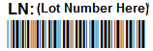
Quantity (Qty) | The Quantity is required and shall be placed on the traceability documentation. The Quantity information content shall consist of the following:  - An alpha-numeric text string starting with “Qty: ” followed by the number of parts contained.  - A linear (one dimensional) barcode consisting of the numeric value only for the number of parts.  Note: Do not include “Qty: ” in the barcode. | 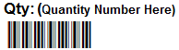
Revision (Rev) | If a Revision exists then the Revision is required and shall be placed on the traceability documentation. The Revision information content shall consist of the following:  - An alpha-numeric text string starting with “Rev: ” followed by the revision.  - A linear (one dimensional) barcode consisting of the Revision value.  Note 1: Do not include “Rev: ” in the barcode.  Note 2: “Rev” applies to HW Part revision if there is a HW revision only. If there is also a Drawing revision then capture both in the following format: HW/DWG. | 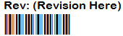
  - Reference: Extract from MIL-PRF-38535K, Appendix A

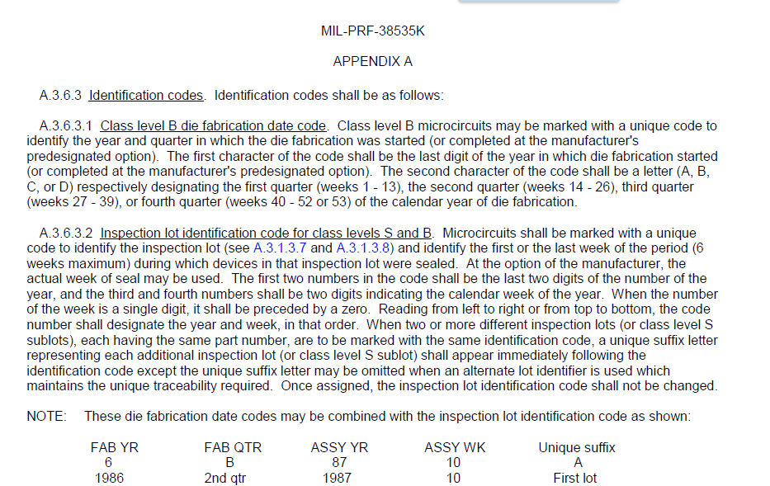

  - Barcoding Constraints

The following Figure depicts how items must appear on each bar code ensuring that traceability data properly will be received properly.

Figure 7

